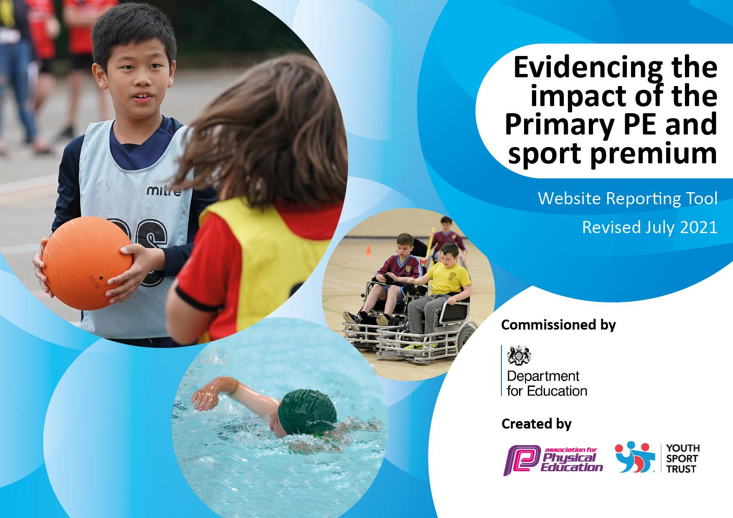
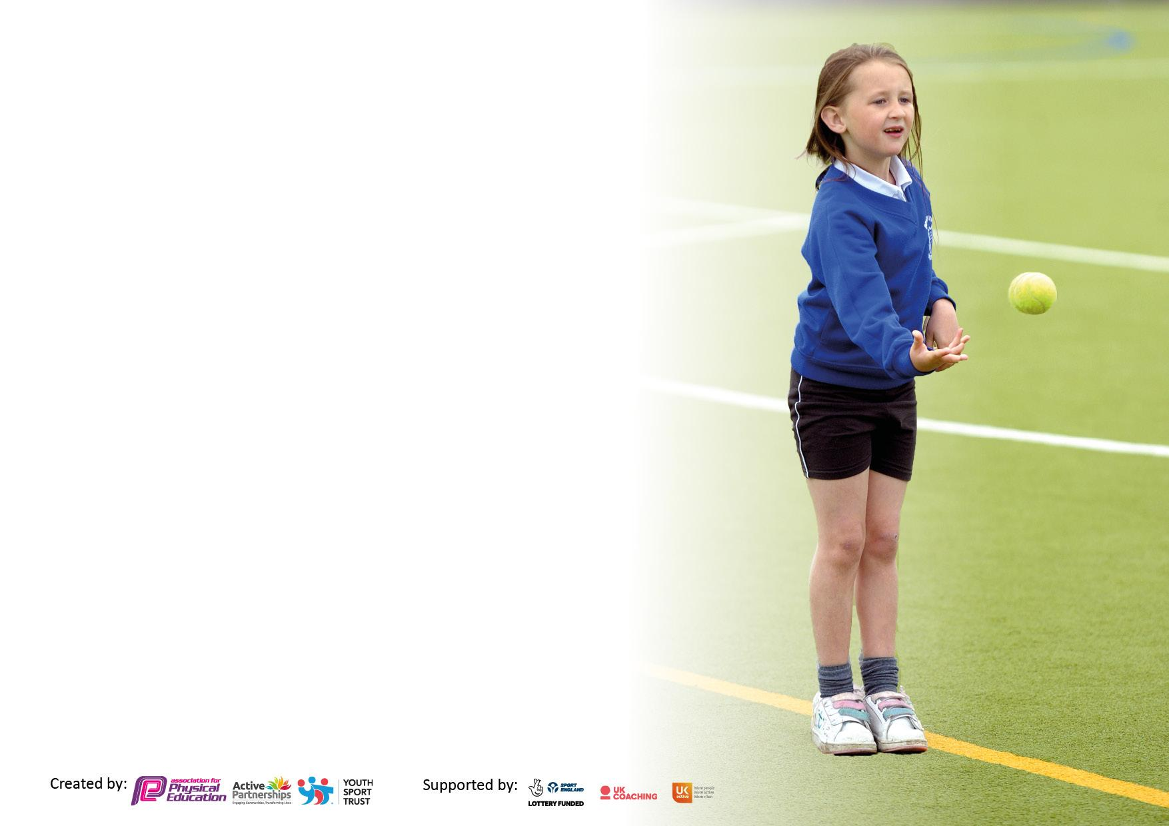

It is important that your grant is used effectively and based on school need. The Education Inspection Framework makes clear there will be a focus on ‘whether leaders and those responsible for governors all understand their respective roles and perform these in a way that enhances the effectiveness of the school’.

Under the Quality of Education Ofsted inspectors consider:
Intent - Curriculum design, coverage and appropriateness
Implementation - Curriculum delivery, Teaching (pedagogy) and Assessment
Impact - Attainment and progress

To assist schools with common transferable language this template has been developed to utilise the same three headings which should make your plans easily transferable between working documents.

Schools must use the funding to make additional and sustainable improvements to the quality of Physical Education, School Sport and Physical Activity (PESSPA) they offer. This means that you should use the Primary PE and sport premium to:

- Develop or add to the PESSPA activities that your school already offer
- Build capacity and capability within the school to ensure that improvements made now will benefit pupils joining the school in future years
- The Primary PE and sport premium should not be used to fund capital spend projects; the school’s budget should fund these.

Pleasevisitgov.ukfortherevisedDfEguidanceincludingthe5keyindicatorsacrosswhichschoolsshoulddemonstrate animprovement.Thisdocumentwillhelpyoutoreviewyourprovisionandtoreportyourspend.DfEencouragesschools to use this template as an effective way of meeting the reporting requirements of the Primary PE and sport premium.

We recommend you start by reflecting on the impact of current provision and reviewing the previous spend.

Schools are required to publish details of how they spend this funding, including any under-spend from 2019/2020, as well as on the impact it has on pupils’ PE and sport participation and attainment. All funding must be spent by 31st July 2022.

We recommend regularly updating the table and publishing it on your website throughout the year. This evidences your ongoing self-evaluation of how you are using the funding to secure maximum, sustainable impact. Final copy must be posted on your website by the end of the academic year and no later than the 31st July 2021. To see an example of how to complete the table please click HERE.

Details with regard to funding
Please complete the table below.

Total amount carried over from 2020/2021 | £0
Total amount allocated for 2022/23 | £20,279
How much (if any) do you intend to carry over from this total fund into 2022/23? | £0
Total amount allocated for 2023/24 | £20,253
Total amount of funding for 2022/23. To be spent and reported on by 31st July 2023. | £20,253

Swimming Data
Please report on your Swimming Data below.

Meeting national curriculum requirements for swimming and water safety.

N.B. Complete this section to your best ability. For example you might have practised safe self-rescue techniques on dry land which you can then transfer to the pool when school swimming restarts.
Due to exceptional circumstances priority should be given to ensuring that pupils can perform safe self rescue even if they do not fully meet the first two requirements of the NC programme of study
What percentage of your current Year 6 cohort swim competently, confidently and proficiently over a distance of at least 25 metres?  N.B. Even though your pupils may swim in another year please report on their attainment on leaving primary school at the end of the summer term 2023.  Please see note above | 61%
What percentage of your current Year 6 cohort use a range of strokes effectively [for example, front crawl, backstroke and breaststroke]?  Please see note above | 55%
What percentage of your current Year 6 cohort perform safe self-rescue in different water-based situations? | 54%
Schools can choose to use the Primary PE and sport premium to provide additional provision for swimming but this must be for activity over and above the national curriculum requirements. Have you used it in this way? | Yes

Action Plan and Budget Tracking
Capture your intended annual spend against the 5 key indicators. Clarify the success criteria and evidence of impact that you intend to measure to evaluate for pupils today and for the future.

Academic Year: 2023/24 | Total fund allocated: £20,253 | Date Updated: 24.11.23
Key indicator 1: The engagement of all pupils in regular physical activity – Chief Medical Officers guidelines recommend that primary school pupils undertake at least 30 minutes of physical activity a day in school |  |  |  | Percentage of total allocation:
 |  |  |  | %
Intent | Implementation |  | Impact
Your school focus should be clear what you want the pupils to know and be able to do and about  what they need to learn and to  consolidate through practice: | Make sure your actions to achieve are linked to your intentions: | Funding allocated: | Evidence of impact: what do pupils now know and what can they now do? What has changed?: | Sustainability and suggested next steps:
Increase the number of different pupils accessing after school activities  Target of 50% of all pupils taking part in at least one half term. | 3 x half term of physical activity clubs to be delivered by Edsential Staff.  Pupil voice used to identify interest and data kept to identify the least active pupils. | Included in Edsential SLA  £6895 | Impact  Evidence
Key indicator 2: The profile of PESSPA being raised across the school as a tool for whole school improvement |  |  |  | Percentage of total allocation:
 |  |  |  | %
Intent | Implementation |  | Impact
Your school focus should be clear what you want the pupils to know and be able to do and about  what they need to learn and to  consolidate through practice: | Make sure your actions to achieve are linked to your intentions: | Funding allocated: | Evidence of impact: what do pupils now know and what can they now do? What has changed?: | Sustainability and suggested next steps:
Develop knowledge and understanding of physical activity related themes such as the relationship between being active and mental health and how nutrition and activity can impact on learning. | A series of workshops for all pupils and staff in the school using specific theme linked to the curriculum. | Included in Edsential SLA | Impact  Evidence
Develop confidence and resilience of pupils through physical activity.  All pupils to demonstrate improved resilience following the visit.  All pupils to demonstrate higher self esteem following visit. | Year 4 outdoor adventurous activities visit planned with clear outcomes for developing resilience and improving self esteem through the challenging activities (out of comfort zone). | £9000 | Impact  Evidence:

Key indicator 3: Increased confidence, knowledge and skills of all staff in teaching PE and sport |  |  |  | Percentage of total allocation:
 |  |  |  | %
Intent | Implementation |  | Impact
Your school focus should be clear | Make sure your actions to | Funding | Evidence of impact: what do | Sustainability and suggested
what you want the pupils to know | achieve are linked to your | allocated: | pupils now know and what | next steps:
and be able to do and about | intentions: |  | can they now do? What has
what they need to learn and to |  |  | changed?:
consolidate through practice:
Improve the quality of teaching and learning, including pupils making more progress in curriculum PE. | Curriculum Support CPD Programme for identified members of staff – 6 week programme using a team teaching format. Programme delivered to 6 teachers in total throughout the year.  Purchase a new online Scheme of Work to support the delivery of a more up to date PE Curriculum. | Included in Edsential SLA  £300 | Impact  Evidence
Develop and support PE Subject Leadership Team;  Improvements in teaching and Learning  Increased physical activity during the day  Assessment and curriculum design | Regular subject leader support meeting will take place with an external advisor. These will focus on all areas of the subject and help the PE team to reflect and improve on current practices in addition to maximising current opportunities. | Included in Edsential SLA | Impact  Evidence
Key indicator 4: Broader experience of a range of sports and activities offered to all pupils |  |  |  | Percentage of total allocation:
Intent | Implementation |  | Impact
Your school focus should be clear | Make sure your actions to | Funding | Evidence of impact: what do | Sustainability and suggested
what you want the pupils to know | achieve are linked to your | allocated: | pupils now know and what | next steps:
and be able to do and about | intentions: |  | can they now do? What has
what they need to learn and to |  |  | changed?:
consolidate through practice:
Broaden the range of activities experienced by pupils, including activities they wouldn’t normally access.  All pupils to access at least 3 new activities.  Pupil voice identifies an increase in motivation and attitudes towards being active.  Increase in the number of pupils accessing clubs and activities outside of school. | Additional Year 4 activities as part of outdoor adventure visit | £9000 | Impact:  Evidence:
 | Plan a programme of local physical activity/new sport experiences for each year group. Includes golf, watersports and rock climbing. | £8000  (£400 per class) | Impact:  Evidence:

Key indicator 5: Increased participation in competitive sport |  |  |  | Percentage of total allocation:
 |  |  |  | %
Intent | Implementation |  | Impact
Your school focus should be clear  what you want the pupils to know  and be able to do and about  what they need to learn and to  consolidate through practice: | Make sure your actions to  achieve are linked to your  intentions: | Funding  allocated: | Evidence of impact: what do  pupils now know and what  can they now do? What has  changed?: | Sustainability and suggested  next steps:
 |  | £
School Swimming |  |  |  | Percentage of total allocation:
Intent | Implementation |  | Impact
Your school focus should be clear  what you want the pupils to know  and be able to do and about  what they need to learn and to  consolidate through practice: | Make sure your actions to  achieve are linked to your  intentions: | Funding  allocated: | Evidence of impact: what do  pupils now know and what  can they now do? What has  changed?: | Sustainability and suggested  next steps:
Increase the number of pupils in Year 6 who achieve the National Curriculum requirements before they leave the school | Catch up programme for targeted Year 6 pupils in Summer 2024 | £2500

Signed off by
Head Teacher: | Phil Dickson
Date: | 24.11.23
Subject Leader: | Andrew Shennan
Date: | 24.11.23
Governor:
Date:

