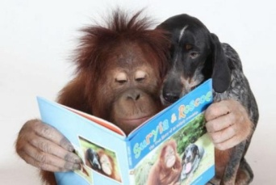**Somerville’s Reading Newsletter**

**Friday 31st January 2020**

**We are readers...**

Welcome back!

**Research shows that sharing stories together has long-lasting effects on a child’s future.** Remember that books you share together can also be recorded in your child’s reading record book, especially if your child does not bring a reading book home each night when following Read Write Inc.

Mrs Fossett

**Books of the Week**

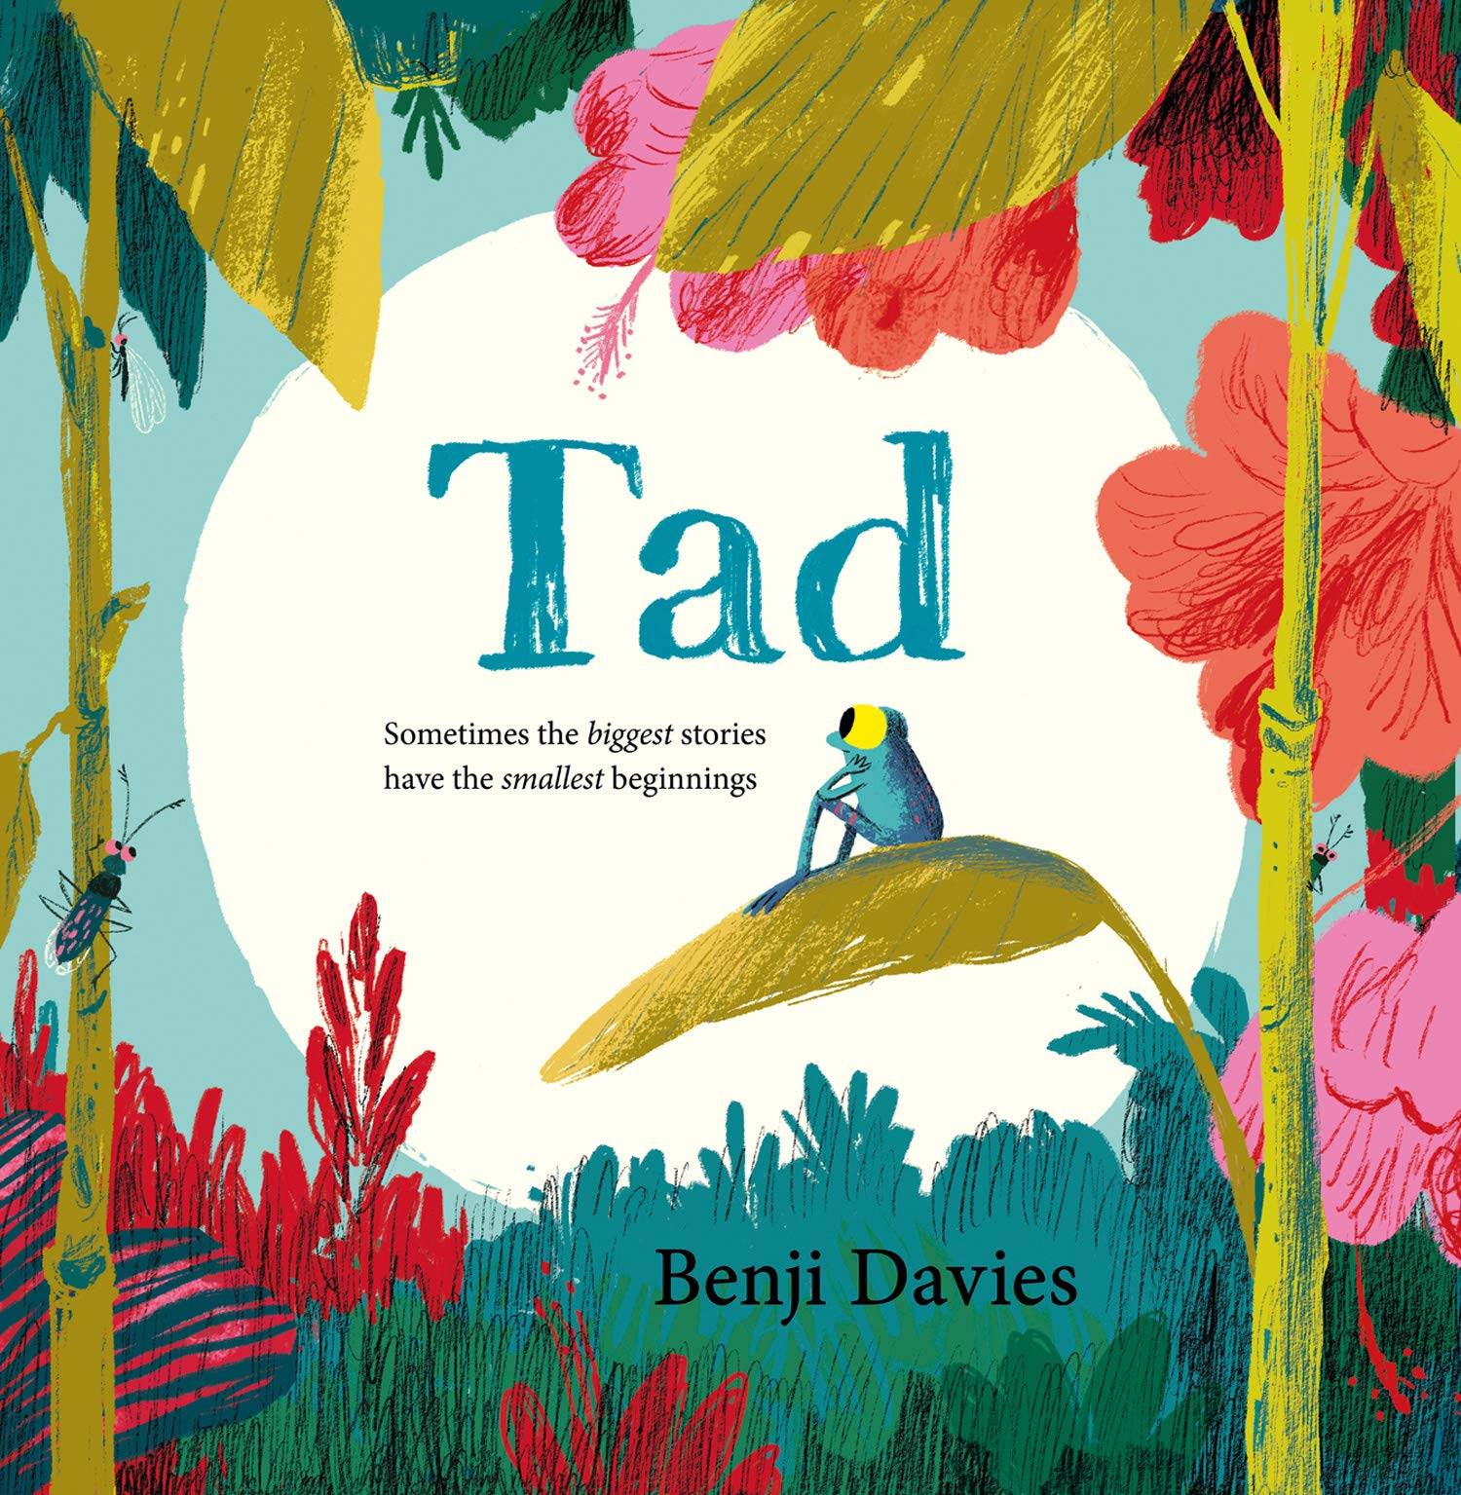

**Tad**

Benji Davies

**Out on 4th Feb!**

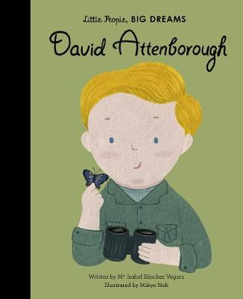

**David Attenborough – Little People, BIG DREAMS**

Maria Isabel Sanchez Vegara



It’s that special time of year to select a book, find a buddy, and read aloud!

[World Read Aloud Day](https://www.scholastic.com/worldreadaloudday) **is happening on February 5, 2020!** The worldwide event from Scholastic and the global literacy non-profit LitWorld calls attention to reading aloud and sharing stories. Now in its 11th year and celebrated in over 173 countries, World Read Aloud Day is a wonderful reminder of the power and importance reading.

Tweet your pictures of you reading with your child. **#WorldReadAloudDay**

**Class of the Week**

Percentage of children who read 3x or more at home

|  |  |  |
| --- | --- | --- |
| **Class** | **Last week** | **This week** |
| Badger | 22% | 31% |
| Bat | 7% | 15% |
| Fox | 7% | 22% |
| Hedgehog | 28% | 24% |
| Otter | 37% | 26% |
| Robin | 50% | 50% |
| Owl | 35% | 62% |
| Squirrel | 22% | 37% |
| Holly | 41% | 61% |
| Maple | 31% | 23% |
| Douglas Fir | 22% | 44% |
| Oak | 43% | 39% |
| Pine | 34% | 44% |
| Silver Birch | 34% | 44% |
| Willow | 48% | 42% |
| Cherry | 52% | **81%** |
| Elm | **59%** | 70% |
| Sycamore | 41% | 52% |

**Well done Cherry class!**

The more you read with your child at home, the better they will become at reading.

**Somerville Favourites**

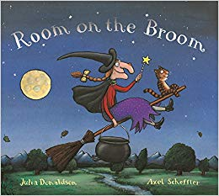

My favourite children's book is Room on the Broom by Julia Donaldson because I love the rhyming and my little girl joins in with the words.

Miss Stevenson