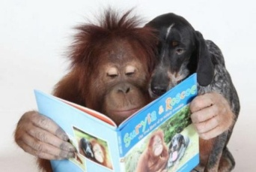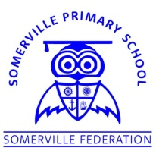**Somerville’s Reading Newsletter**

**Friday 28th February 2020**

**We are readers...**



We will be celebrating World Book Day on **Thursday 5th March** and we are inviting the children to dress up as their favourite book character. There will be a prize for the most unique character in each class. Children are welcome to bring in their favourite book to share with their friends. Children will all receive their £1 book token to spend on one of the selected books or towards any book in supermarkets and bookshops.

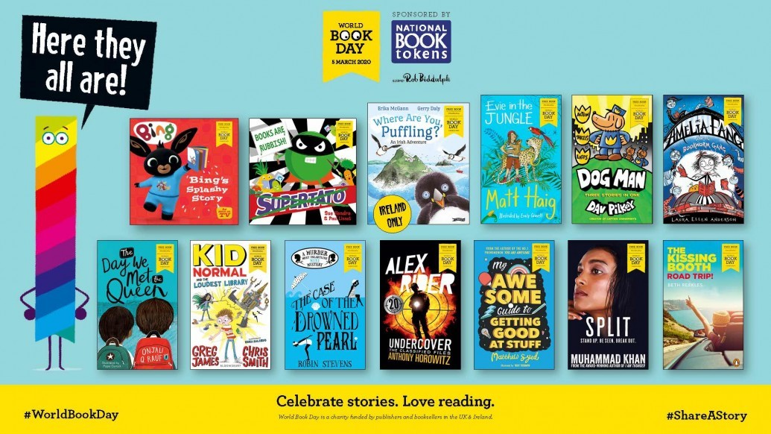

**Book Tower Photo Competition**

Take a photograph of your child with a tower of books that they have read recently. Please bring in your photographs by **Monday 2nd March** and winners will be announced on World Book Day. Thank you for all of the photographs so far.

**Reading for Pleasure Week**

**2nd – 6th March**

We will be reading fairy tales and classics across the school. Please ask your child about their story throughout the week.

F2 – The Emperor’s New Clothes

Y1 – Tom Thumb

Y2 – Hansel and Gretel

Y3 – Robin Hood

Y4 – Robinson Crusoe

Y5 – The Wizard of Oz

Y6 – The Secret Garden