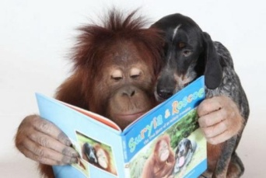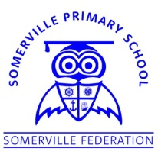**Somerville’s Reading Newsletter**

**Friday 6th March 2020**

**We are readers...**

Hello everyone,

Wow!

What a fantastic range of costumes for World Book Day! Thank you to all of the parents for helping your children to celebrate this day with us.

Have a look at our school website and Twitter pages for photographs from the day.

Mrs Fossett

**Books of the Week**

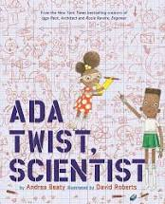

**Ada Twist Scientist**

Andrea Beaty

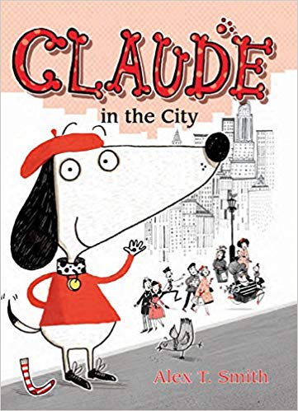

# Claude in the City

## [Alex](https://www.thebookpeople.co.uk/webapp/wcs/stores/servlet/browse_author_books?author=Tom+Oldfield) T Smith

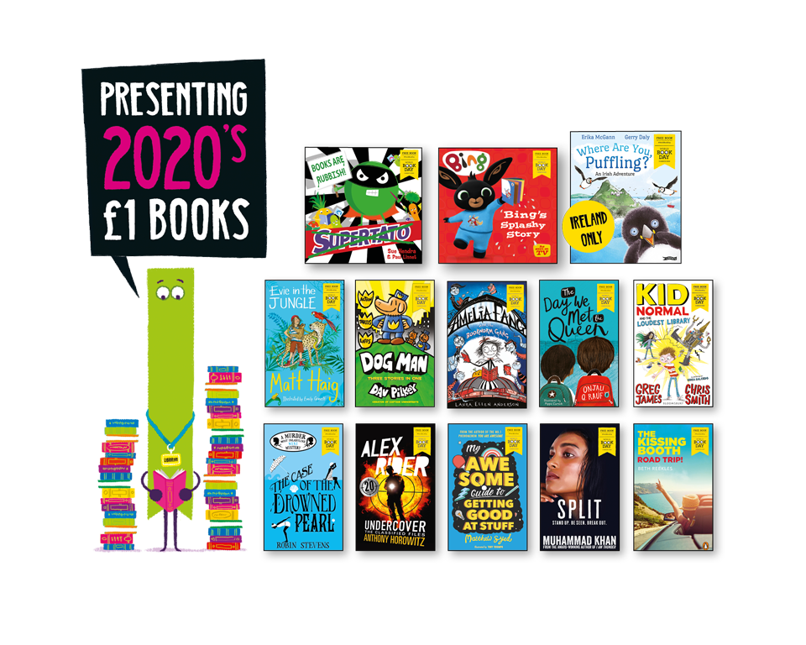Now you have your book token, all you need to do is to take it to your local bookseller (including supermarkets) and swap it for one of the FIFTEEN exclusive, new and completely FREE World Book Day books.

Or, if you’d prefer, you can use your book token to get**£1 off** any full price book instead.

**Class of the Week**

Percentage of children who read 3x or more at home

|  |  |
| --- | --- |
| **Class** | **This week** |
| Badger | 38% |
| Bat | 48% |
| Fox | 41% |
| Hedgehog | 28% |
| Otter | 26% |
| Robin | 54% |
| Owl | 54% |
| Squirrel | 15% |
| Holly | 50% |
| Maple | 27% |
| Douglas Fir | 38% |
| Oak | 55% |
| Pine | 41% |
| Silver Birch | 53% |
| Willow | 58% |
| Cherry | **63%** |
| Elm | 59% |
| Sycamore | 59% |

**Well done Cherry class!**

The more you read with your child at home, the better they will become at reading.

My favourite books is The Way Back Home by Oliver Jeffers because it shows how two people who didn't know each other, were able to help one another and become friends for life.

Mrs Forsythe

**Somerville Favourites**

